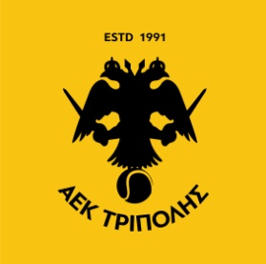SMALL GROUP

MΗΝΑΣ : ΑΥΓΟΥΣΤΟΣ 2022

SUNDAY MONDAY TUESDAY WEDNESDAY THURSDAY FRIDAY SATURDAY



19

18

17



22

23

25

26

24



31

30

29

COPYRIGHT © 2022 // GEORGE PAPADOPOULOS COACHING TEAM | DO NOT COPY OR SHARE

ΩΡΕΣ ΤΜΗΜΑΤΩΝ: 18:00 – 19:00 – 20:00 – 21:00